**Home Page**

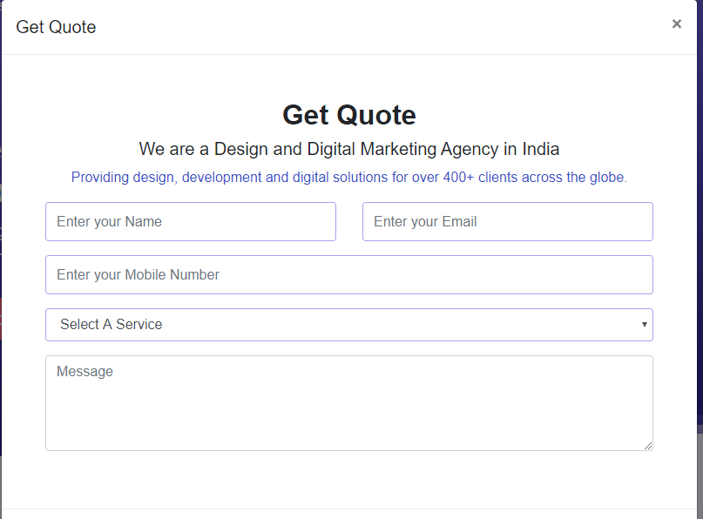

I highlighted this mistake multiple time

Please Reduce the Size of the Form it was covering the entire Screen.

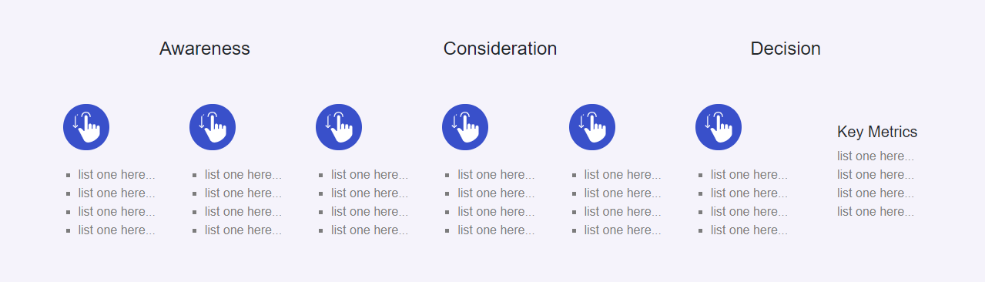

**Please Insert The Below content in the box because the content is same for my website too. Also please increase the size of the circle so that content inside the circle visible to users.**

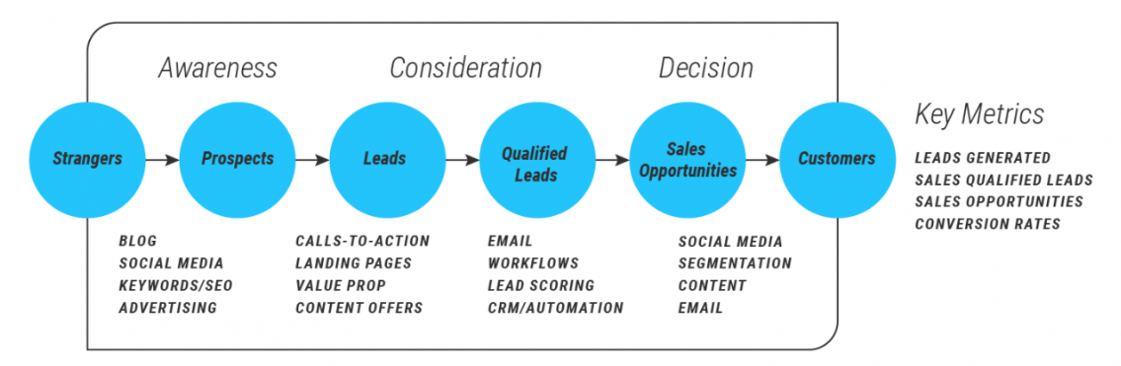Also please use only one H1 tag on a single page rest of the Headings will be h2, h3, h4.

**Product page**

Why Last Box of Client Review Section is half .Please Check

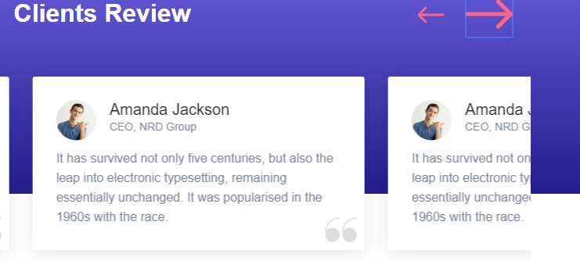

I highlighted this mistake multiple time

**WEBSITE CONTENT- LEARN MORE PAGE**

Order Now Button Not Working

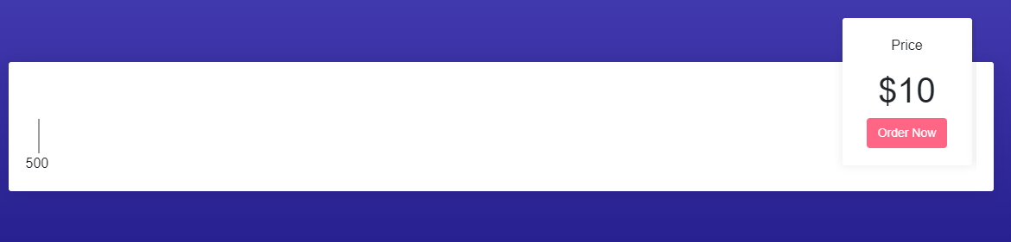

This is a Scroller where the price will change according the Upper Box Move on the Word. Please Review the first document regarding price terms

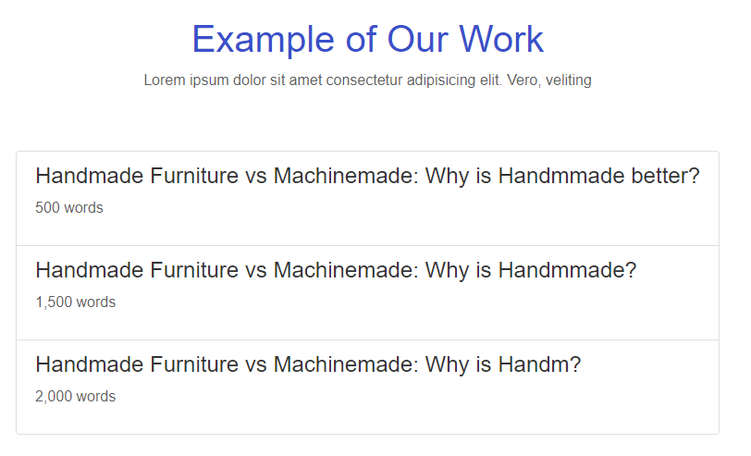

I highlighted this mistake multiple time

The title will work as a link and after clicking on the link a model will appear which will show the sample of the article.

Previously it was working but right now it’s not working, please check

**Website Content – Marketing Designs**

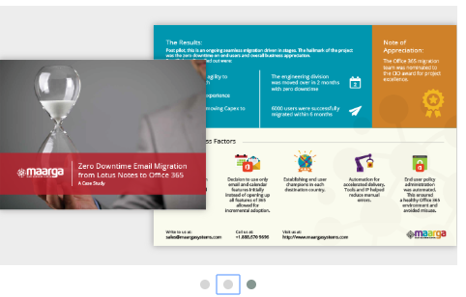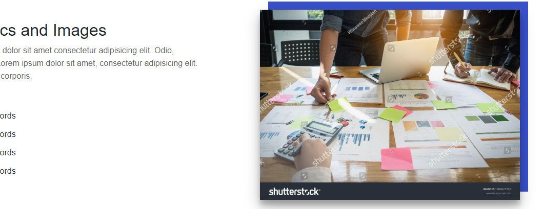

Something like this

This is a Image Slider where we show multiple Images. Please make this section a slider



This Button is Not Working Please Check

**Digital – Search Engine Marketing (SEM) Please Do the same Correction in all three pages .**

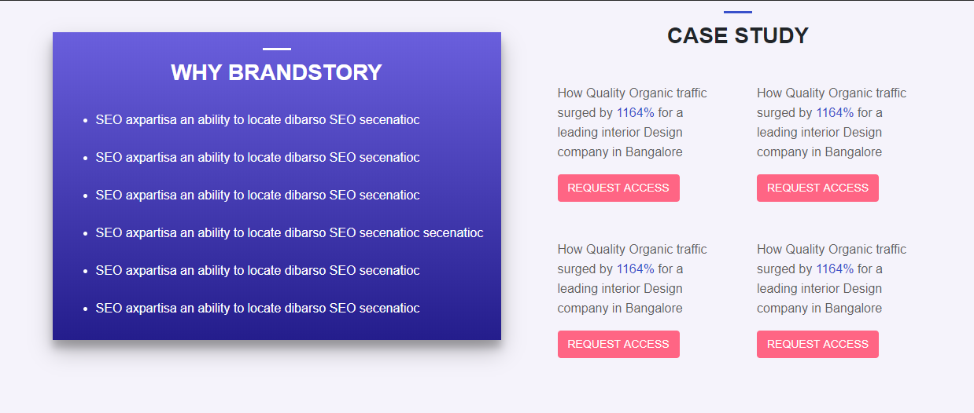

Also Please Review the Design of this Section in the Design Page and make the certain changes.

After Clicking ON Request Access a model form will appear and they ask for please insert your email

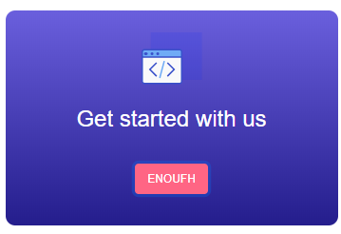

This Button is Not Working. Please Check and also change the name of Button to Get Quote

**\*\*\*Both the Pages of Enterprise is completely different from my design, Please follow think below link for design overview (**<https://brandstory.in/enterprise/enterprise-seo-services/>).

Please mark this point and make it similar to the link mentioned below. Or Even the Design Specification of Both the pages are mentioned below;

There is some change in the Enterprise Section and The Design of both the pages in Enterprise Section is at the end of this page after Red Line

**UI/UX Page**

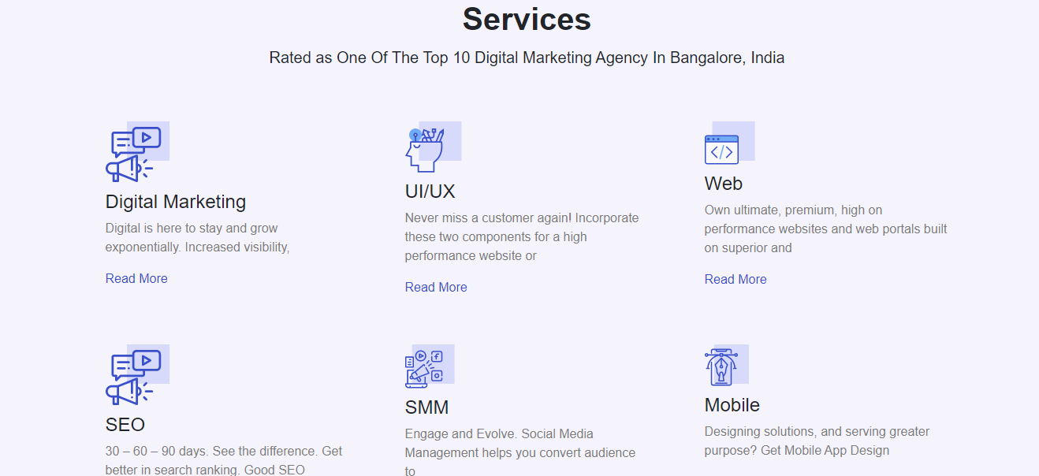

Instead of Placing Service Section in the UI/UX page Please add the Process of UI/UX development. Below is the Reference link

<https://brandstory.in/uiux/mobile-app/>

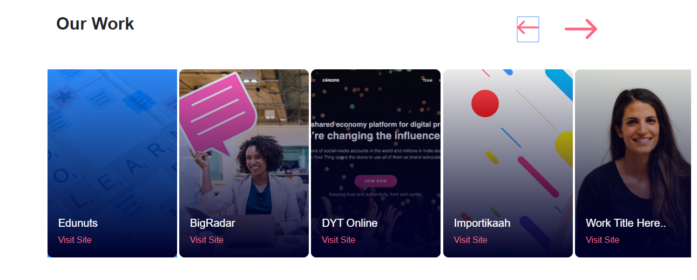

Instead of Placing this type of Section to Show our Work can we put a image slider and a content box where one side we will put the images of our work sample and other side we write content for our work

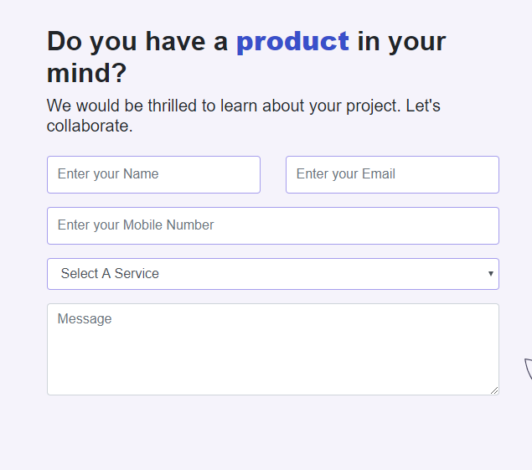

Submit Button is missing in the form. Please Add Submit Button

**Web Development**

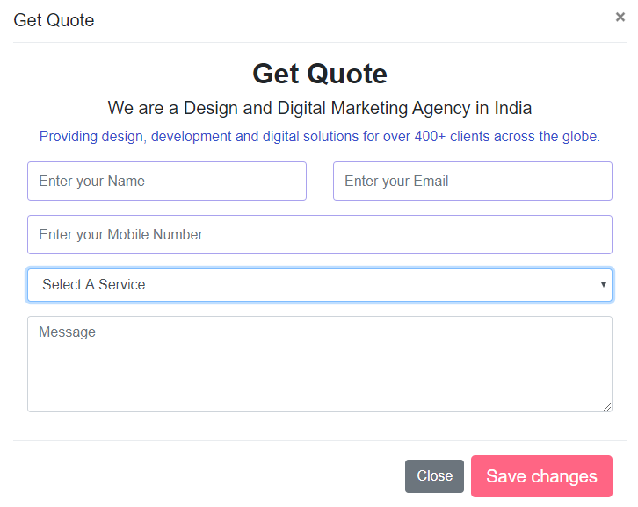

Why Save Changes Button instead of submit button

Dropdown Not Working

**Also I want to know why the design of ui/ux page and Website Development Page is same , bacuese previously the design was different and it looks good why you are placing similar design in all the pages.**

**WEB Development (The Previous Design is Good only need some modifications) Please Insert the Previous Design and after that I will let you know about the changes.**

**Enterprise**

LEAD GENERATION

CONTENT MARKETING

1. **Enterprise – LEAD GENERATION PAGE**

* **The top section contains a Banner with the same colour Background with Title inside <h1> tag, a paragraph contains 3,4 line and a process svg graphics which I will explain in the Graphic Section.**

<h1> Best Lead Generation Company in Bangalore </h1>

<p> Content </p>



* 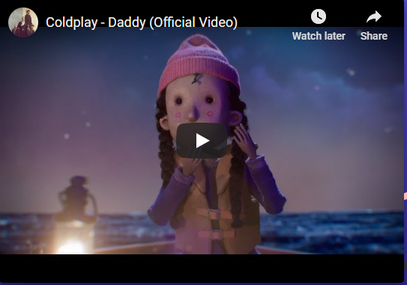Next to banner insert a section which is like a title with a pargarph and video as on the other side.

<h2> Why We are Best in Lead Generation? </h2>

<p> Content </p>

* Third Section: This section is divided into two equal parts first part is of same colour like Banner and it is divided into two parts horizontally, thetop section contains the image and the bottom section will contain a 4,5 line content. Meanwhile the second part of the same section contains a form. The design of the sections are mentioned below



Submit

Mention Your Major Challenges

Contents (please add 4,5 checkboxes)

Company Name:

Purpose:

Email:

Name:

Content Paragraph

* Fourth Section: In this section you have to insert a thin section which is divided into two parts first section contains the image and second section contains the Content with a title



<h2> title </h2>

<p> Paragraph </p>

* Fifth Section: This Section Contains a Header which is “Strategy & Execution” below that heading a small 1,2 line content. After that a set different boxes which contains the Box icon and each boxes are connected with each other with a dotted line showing the Relation between the two. Also there is a Title below each box.
* Sixth Section: This section is divided into two parts. First Section again divided into two pair, the top section contains a title with a small paragraph and bottom section contains the image. The second section contains a list of items which is clickable and the content of the left box will changes after clicking on the list of different item in the right side box.



Product Marketing

Technology Marketing

Sales Lead

IT Company Leads

B2B Lead Generation

Title

Paragraph

* Seventh Section : This is a last section which contains a bold lines along with a CTA which is Request for Proposal .

Request for Proposal

Bold Content Like a title

Reference Link: <https://www.ironpaper.com/lead-generation/>

1. **Enterprise – CONTENT MARKETING**

The Design the Content Marketing Page is similar to Lead Generation Page. Only few Changes in the Content Marketing Pages and that is

* Fifth Section of the Lead Generation Page is going to be change and the design of the process are shown below

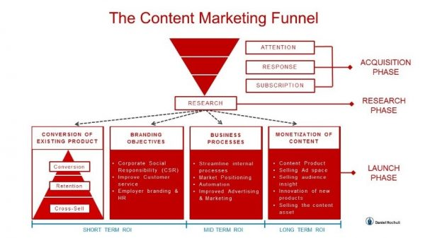

You can change the design and color combination but the content is same.

**Design of the Enquiry form for Both Pages are**

Want to Boost Your Sale

Need Digital Marketing Support

Want to Know About Our Email Marketing Package

Others

Need Content For Marketing

Want Support in Lead Generation

Why You Want to Connect with SeoStreet?

**SUBMIT**

This is a Drop down Section and Contains:

* Request For Proposal
* Want to Collaborate
* Digital Marketing
* Others

**Purpose:**

**Phone No:**

**Company Name:**

**Email:**

**Name:**

**WEBSITE CONTENT – MARKETING DESIGNS**

**\*\*\*After Clicking on Know More Button a from will appear and error in the form are mentioned below.**

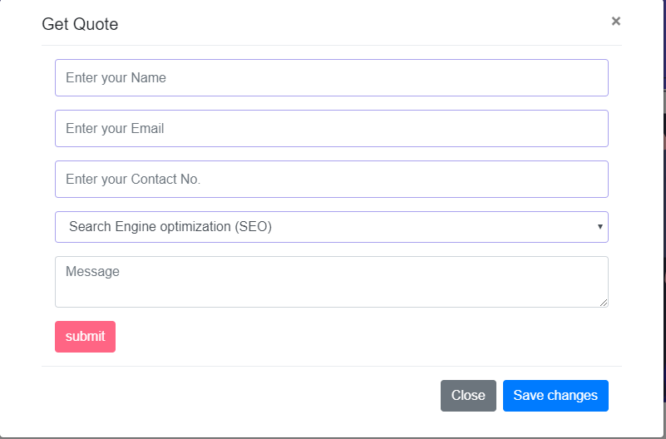

So, what’s the use of this button? Please Remove the Below Button

There Is Submit Button and on the Top of the form there is Close Button

There is same problem with the Get Quote Form Too. Please Correct both forms.

Extra Work;

* Please make one extra page which is like a template so that if we want to add any extra pages inside our website I can also add.
* Please Make a Model popup which is appear while user open the site or reload the site. It’s a small model which contain a design one side and on the other side it contains a form. The sample of the Popup Model are given blow;